Practice Module-Human Spec Sheet 10/19/13

Purpose: To describe the layout of the PM-Human; this practice module will teach the user how to interact with controls when they are playing as CCC-Human.

**Graphic Definitions:** This section will define general descriptions of the graphics in the layout of the module:

**Path:** This will be a group of graphics that will all move at the same rate; there are several layers of graphics within the Path. The rate this layer moves depends on the action called (see Human Spec Sheet).

**Boundaries**: These graphics will be simple lines defining the boundaries that CCC will interact with. They will be on the same layer that is occupied by the CCC graphics. These graphics will be kept transparent so that the user does not see the lines. The holes, walls, gaps, and bumps in the boundaries have been placed specifically so that specific actions (e.g jumping or crawling) must be used to move along or around the boundary lines.

**Back Graphics:** These graphics will be contained in the layer directly beneath the Boundaries layer. These will provide visual representations of the boundary lines. It will appear that the user is interacting with these graphics. CCC will be in front of these graphics.

**Fore Graphics**: These graphics will be contained in the layer directly above the Boundaries layer. They will appear to give the game depth as CCC will move behind the objects in this layer.

**Background Graphics**: These graphics will move slower than the Path graphics, hopefully, creating a parallaxing effect. The sole purpose of these graphics is to give the game more depth. These graphics will be on a layer beneath the Path graphics; the Path will move in front of these graphics.

**Foreground Graphics**: These graphics will move faster than the Path graphics, another parallaxing effect. The sole purpose of these graphics is to give the game more depth. These graphics will be on a layer above the Path graphics; the Path will move behind these graphics.

**Sky**:This layer will contain a simple box that will serve as the sky. This layer will not move at all and will be the bottom-most layer.

**Instructions**: To teach the user how to interact with the actions associated with this CCC, sound bites, action demos, and text will appear at different trigger points. These trigger points will be a specific location along the Boundaries or objects that the user collides with. The animations will not move with respect to whatever user action is being called at that moment.

**Layout:** Refer to Figures 1 and 2 for the layering scheme of PM-Human. Refer to Figure 3 for the location of triggers, objects, and obstacles in PM-Human. Table 1 describes the triggers, obstacles, and objects.

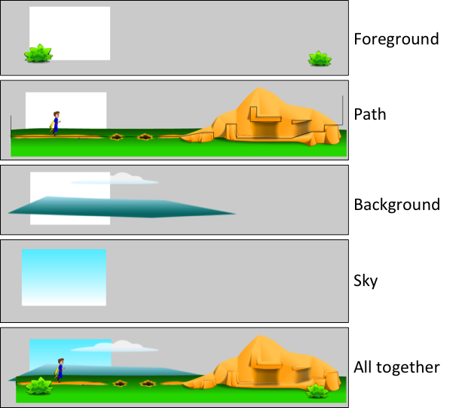

Figure 1. In order from top most layer to bottom most layer: Foreground, Path, Background, Sky. The final picture is all of the layers compressed together.

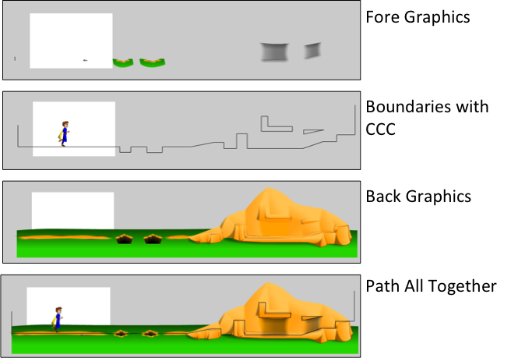

Figure 2. In order from top-most layer to bottom most layer: Fore Graphics, Boundaries with CCC, Back Graphics. The final picture is all of the layers compressed together.

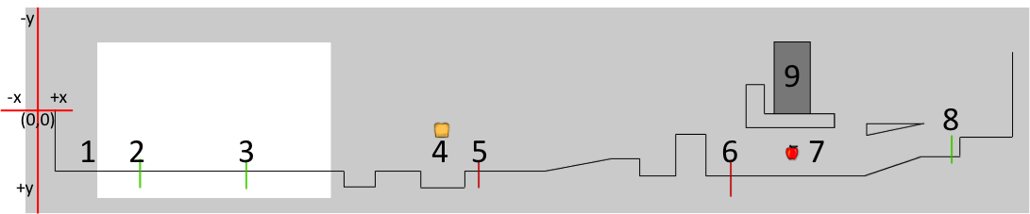

Figure 3. A map of the triggers and objects with respect to the boundaries with x and y axis labeled on the left. Points 1-9 are described in Table 1. **NOTE**: the y-axes is upside-down.

Table 1. This table describes all of the important points within the module.

|  |  |  |  |
| --- | --- | --- | --- |
| Boundary Object Dimensions (px): 3934.50 x 636.15 | | Boundary Object Origin Location: Middle of the Left Edge | |
| **Point** | **Purpose** | **Actions Called** | **Location (x,y)** |
| 1 | Where CCC will generate upon entering the PM. | CCC will start in “Standing”.  **After 1 seconds, the instructional animation, “Walking” will play.** | N/A |
| 2 | As user walks past, explain how to run. | When pass, play “Running” animation. | (336, 182.25) |
| 3 | As user passes, explains jumping | When pass, play “Jumping” animation. | (772.15, 182.25) |
| 4 | User “eats” the bread and gains energy. | The “Bread” object will have an action associated with it so that the user’s energy score changes. After collision “Bread” disappears. | (1574.65, 12.95) |
| 5 | Explains the energy point system. | When the player makes it to this spot, AG-“Standing” and the “Energy” animation are called. No other actions can be called until “Energy” is finished playing. | (1728.35, 182.25) |
| 6 | Explains how to crawl. | When the player makes it to this spot, AG-“Standing” and the “Crawling” animation are called. After AG-“Standing” is called, other actions can be called. | (2764.6, 200.45) |
| 7 | User “eats” the apple and gains energy. | The “Apple” object will have an action associated with it so that the user’s energy score changes. After collision, “Apple” disappears. | (3015.6, 103.6) |
| 8 | Explains how to stand up. | When pass, play “Stand Up”. | (3672.85, 120.9) |
| 9 | Exit the practice module. | When collide with the door object, takes user back to Human Practice Module page. | (3014.65, -356) |